20th May 2019 Shivam Sharma 11-B

Computer Science Holiday Homework

Python Computer Language

# List of **Python** Programs

* Program to find *the area* and *perimeter* of a Rectangle.
* Program to find *the area* and *perimeter* of a Right Triangle.
* Program to find the *area* and *circumference* of a Circle.
* Program to find *Simple* Interest.
* Program to find *Compound* Interest.
* Program to *convert* Temperature from *Celsius* into *Fahrenheit* and vice-versa.
* Program to make a *Report* Card from marks of a student.
* Program to find the *sum*, *difference*, *product* and *quotient* of two variables.

# 1.1 Program to find *area* and *perimeter* of a Rectangle

* Code Snapshot

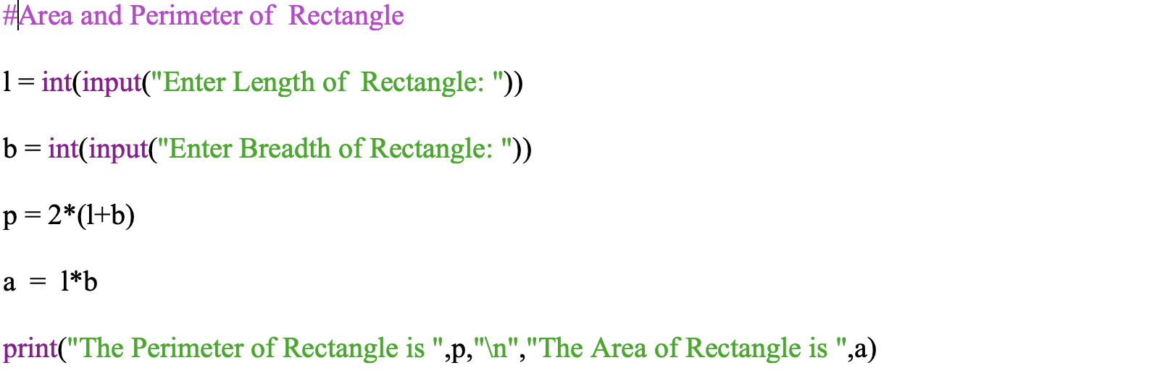

* Explanation

The following code works by taking length and breadth as input from the user and calculates the area and perimeter of the rectangle.

* Output

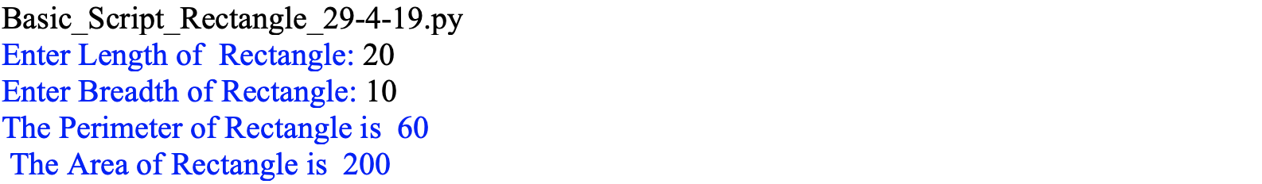

# 1.2 Program to find *area* and *perimeter* of a Right Triangle

* Code Snapshot

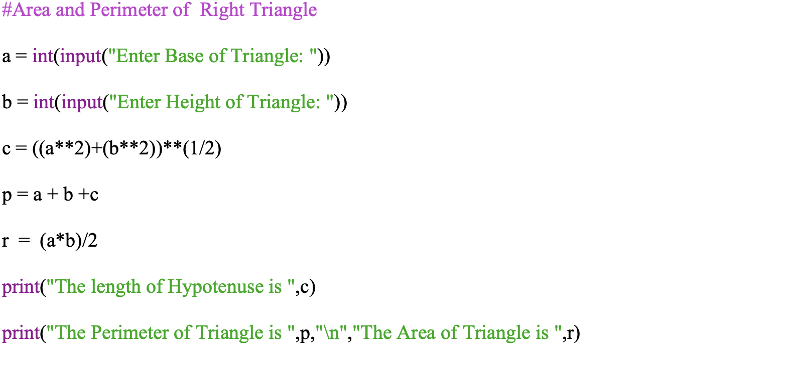

* Explanation

The following code works by taking base and height as input from the user and calculates the length of the hypotenuse, area, and perimeter of a right triangle.

* Output

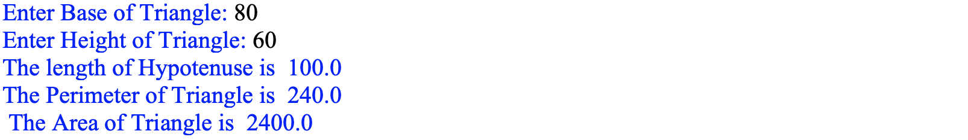

# 1.3 Program to find *area* and *circumference* of a Circle

* Code Snapshot

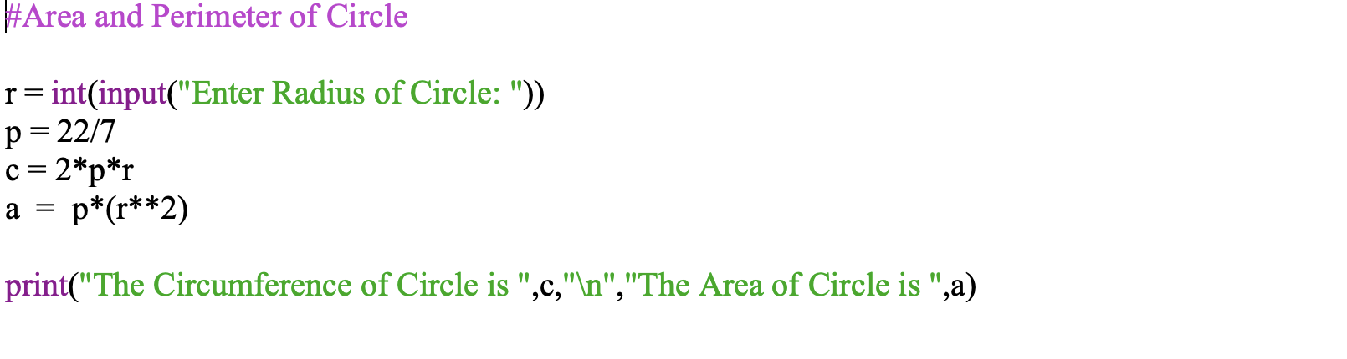

* Explanation

The following code works by taking the radius of the circle as input from the user and calculates the circumference and area of a circle.

* Output



# 1.4 Program to find *Simple Interest*

* Code Snapshot

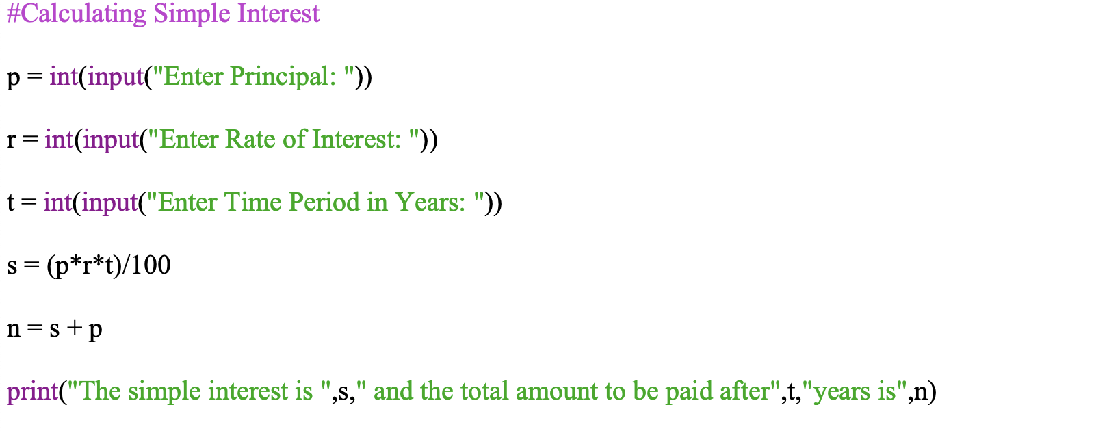

* Explanation

The following code works by taking the principal amount, rate of interest and time period as input from the user and calculates the simple interest and total amount to be paid after given the time period.

* Output

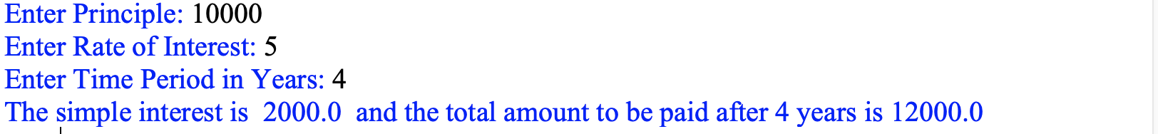

# 1.5 Program to find *Compound Interest*

* Code Snapshot

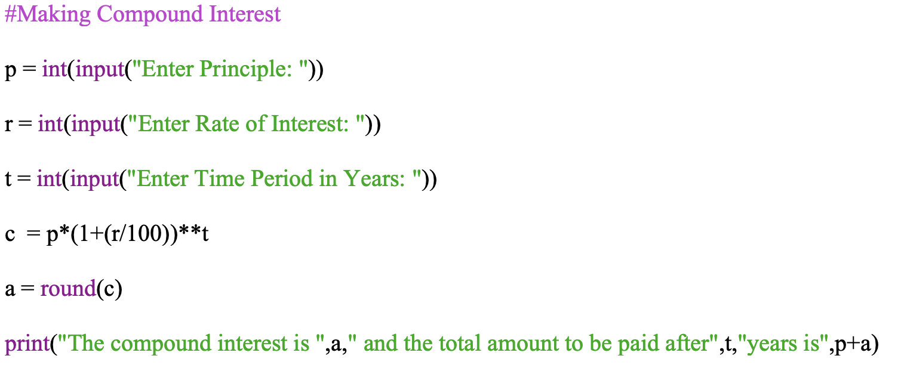

* Explanation

The following code works by taking the principal amount, rate of interest and time period as input from the user and calculates the compound interest and total amount to be paid after the given time period.

* Output

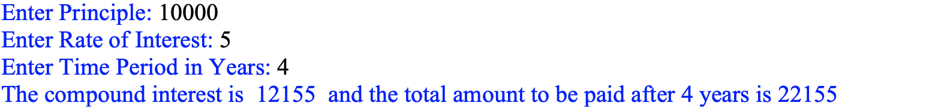

# 1.6 Program to convert Temperature from *Celsius* into *Fahrenheit* and vice-versa

* Code Snapshot

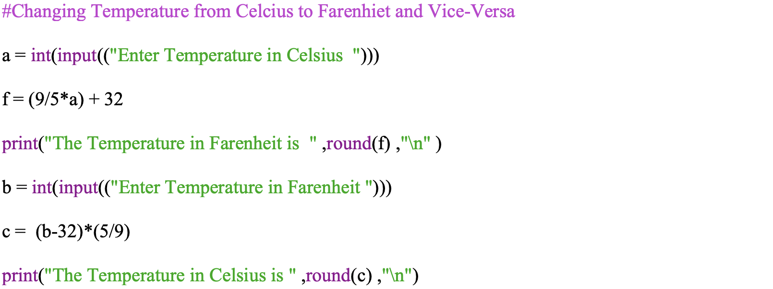

* Explanation

The following code works by taking the temperature in both Celsius and Fahrenheit as input from the user and calculates Celsius into Fahrenheit and vice versa.

* Output

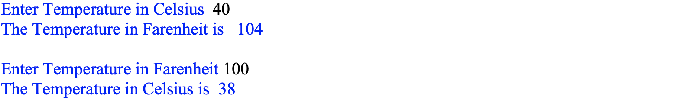

1.7 Program to make a *Report* Card from marks of a student

* Code Snapshot

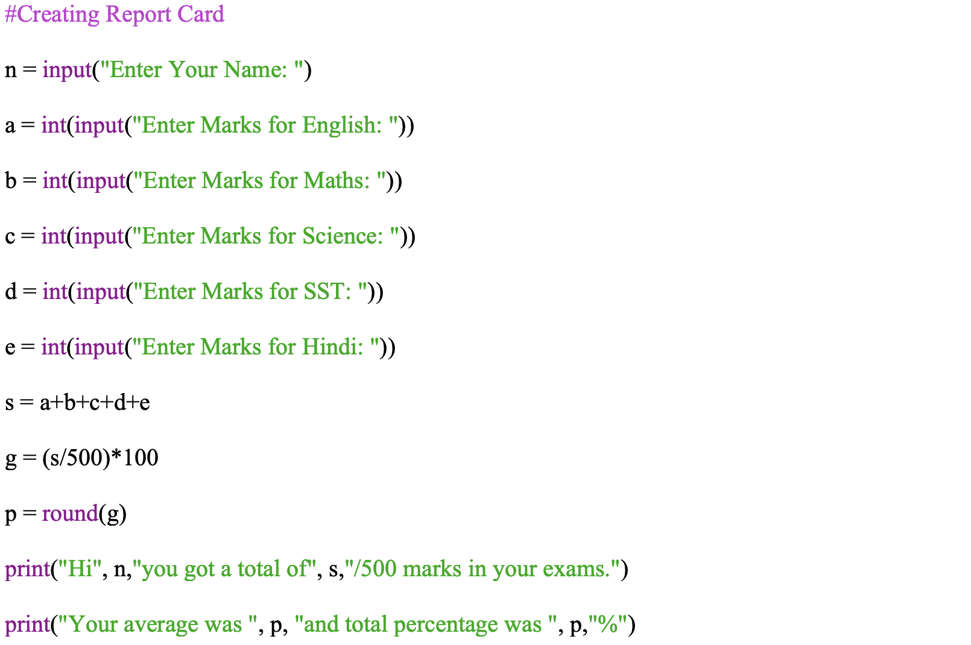

* Explanation

The following code works by taking the marks of the student as input from the user and calculates the average marks and percentage obtained by the student in the examinations.

* Output

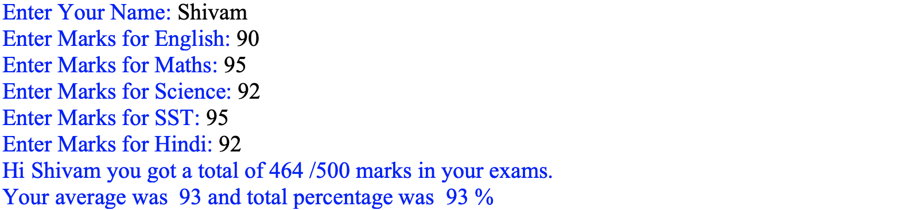

1.8 Program to the *sum*, *difference*, *product*, and *quotient* of two variables

* Code Snapshot

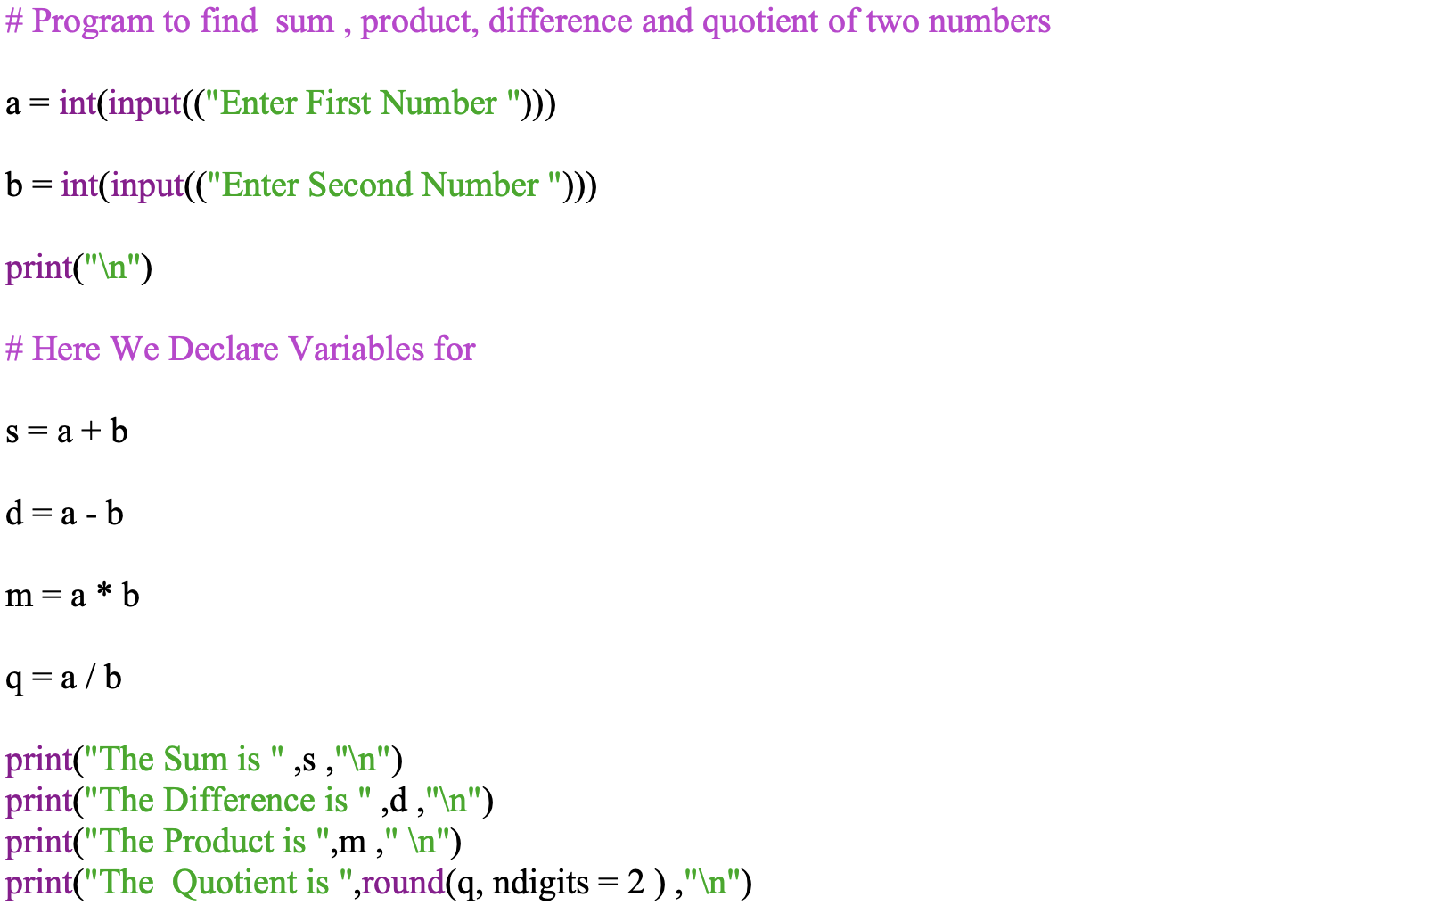

* Explanation

The following code works by taking 2 numbers as input from the user and calculates the sum, difference, product and quotient of the given 2 numbers.

* Output

